**INFO6205 - Program Structures and Algorithms**

**Assignment 01** - Random Walk Algorithm

**Implemented Functions marked as “FIXME” in RandomWalk.java class file**

* **move(int dx,int dy)**
* **randomWalk(int m)**
* **distance()**
* **Main method in RandomWalk.java for custom test cases**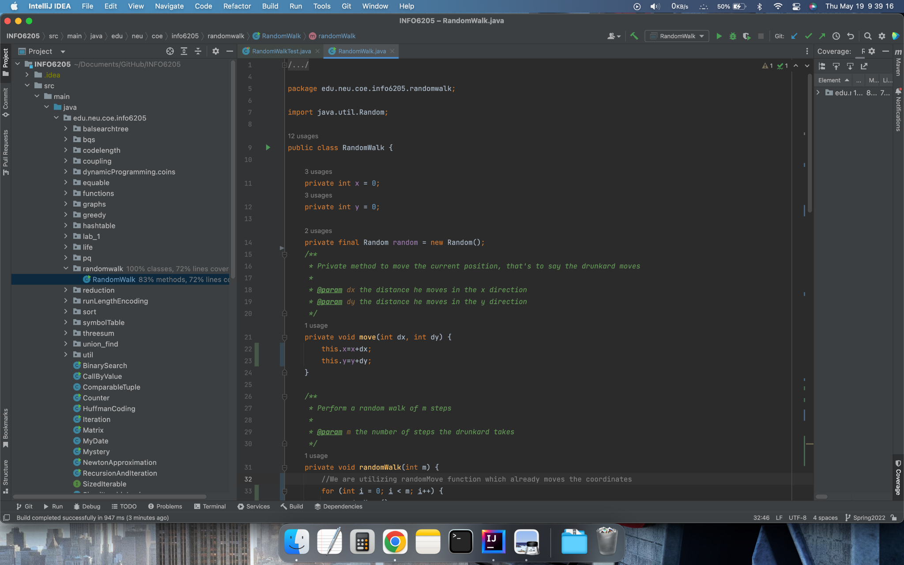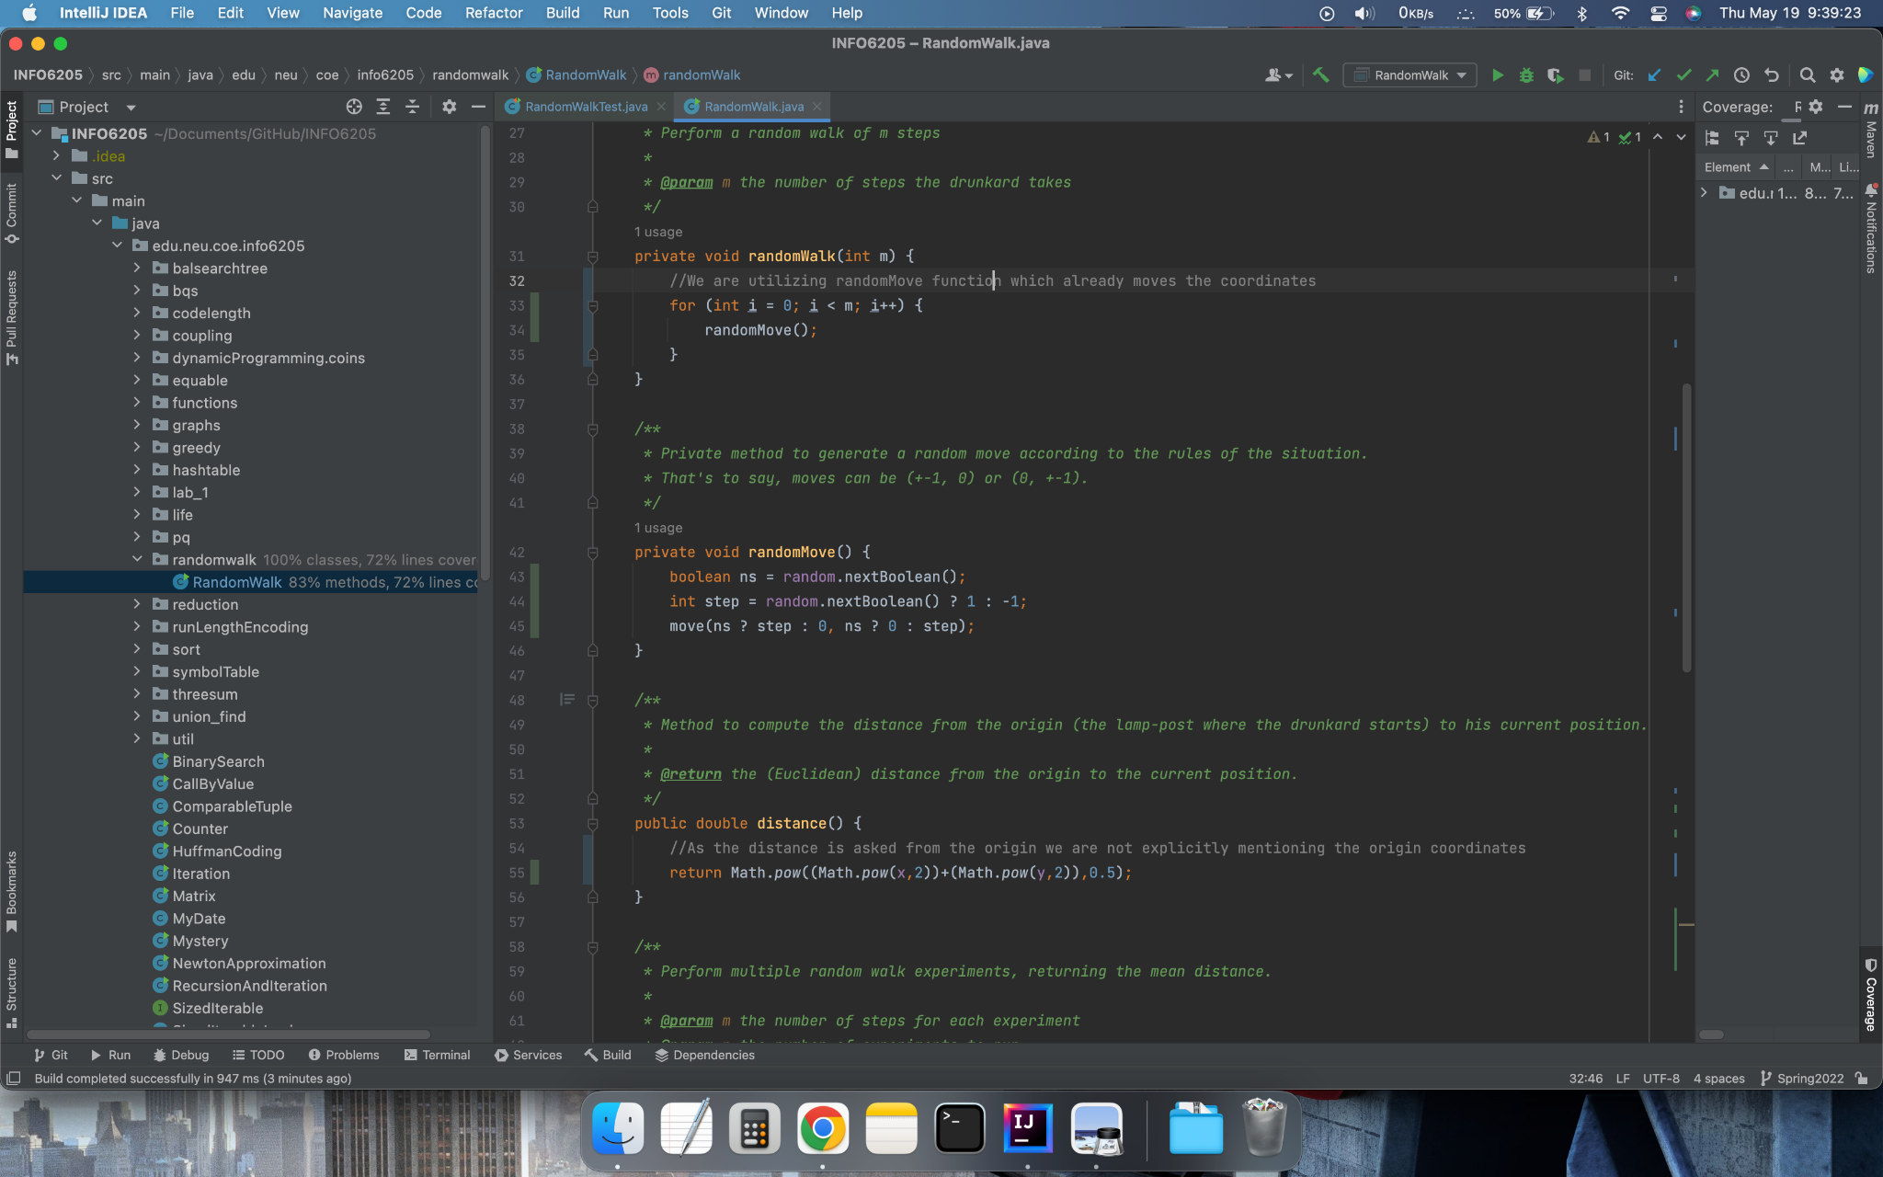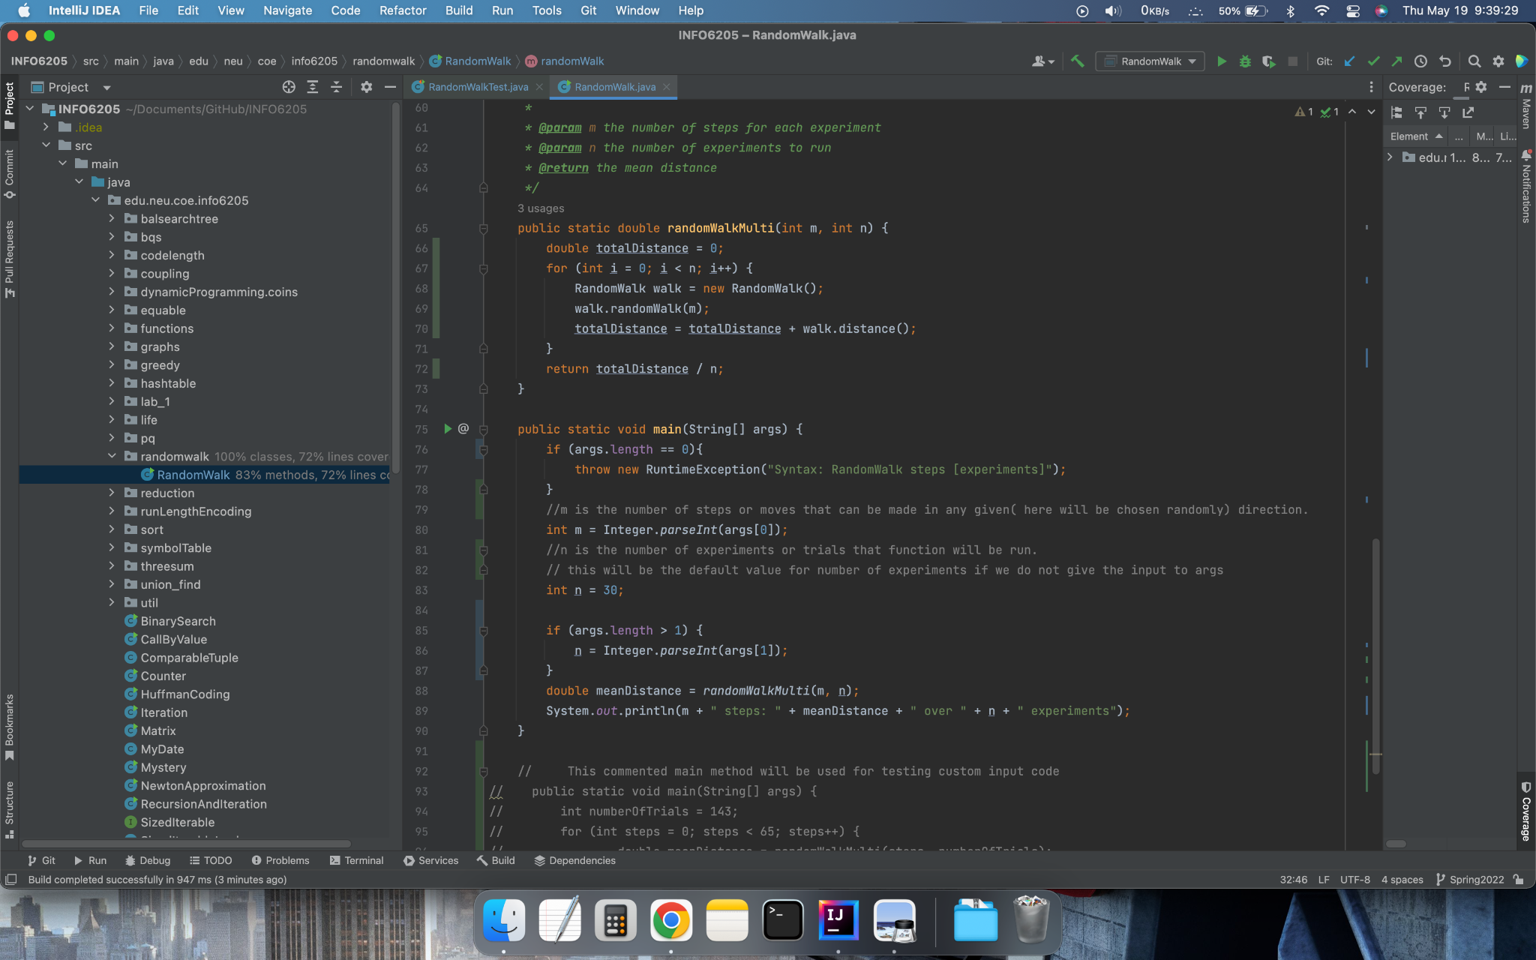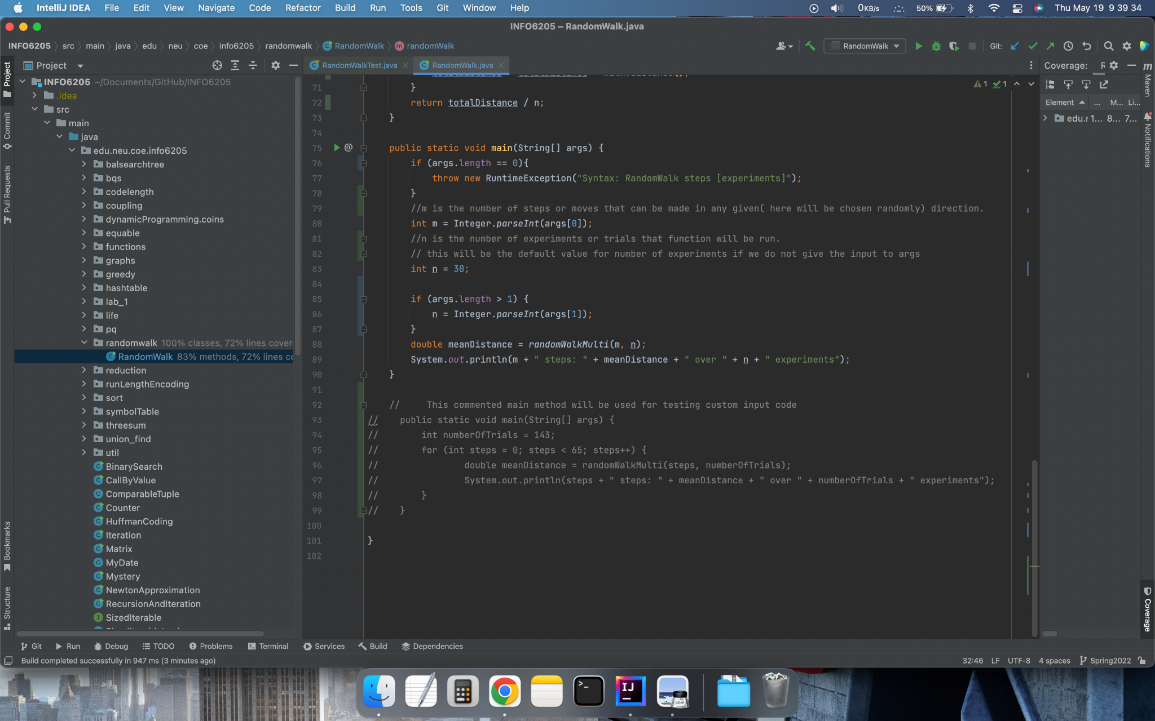

**All Test Cases Are Running for the implemented code - Attached > Test Cases + Test Results**

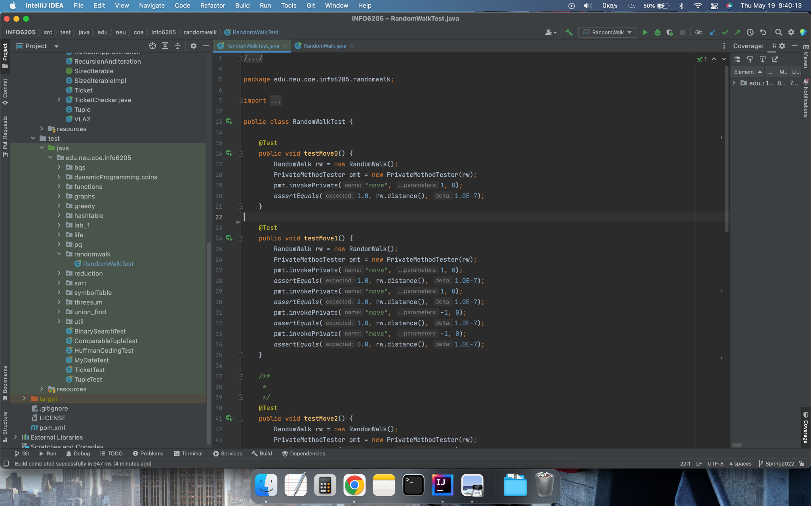

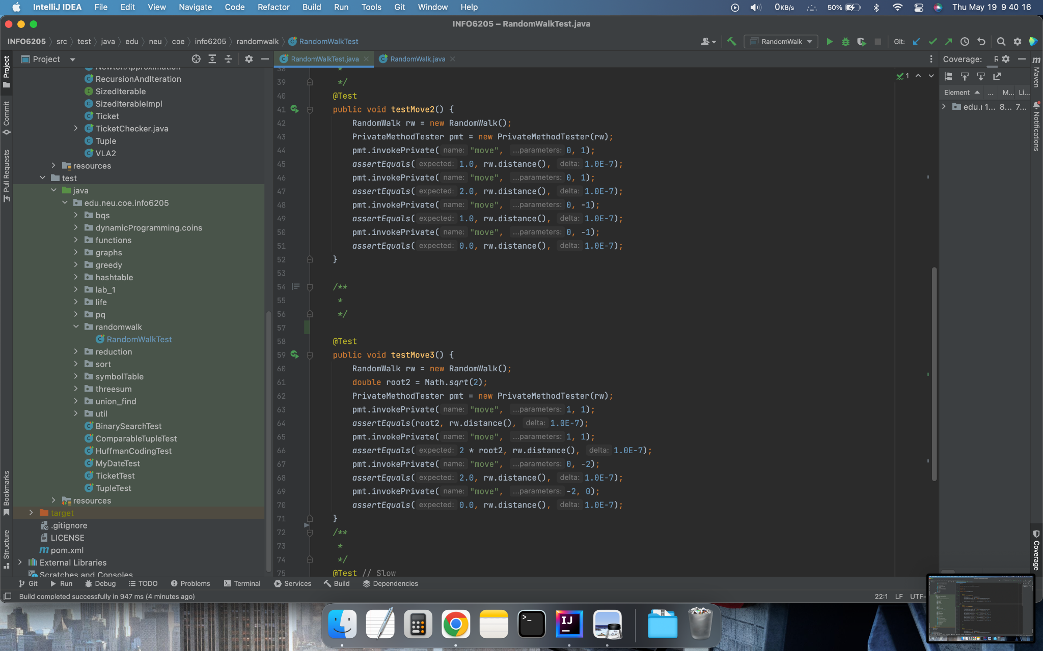

**All Test Cases were passed**

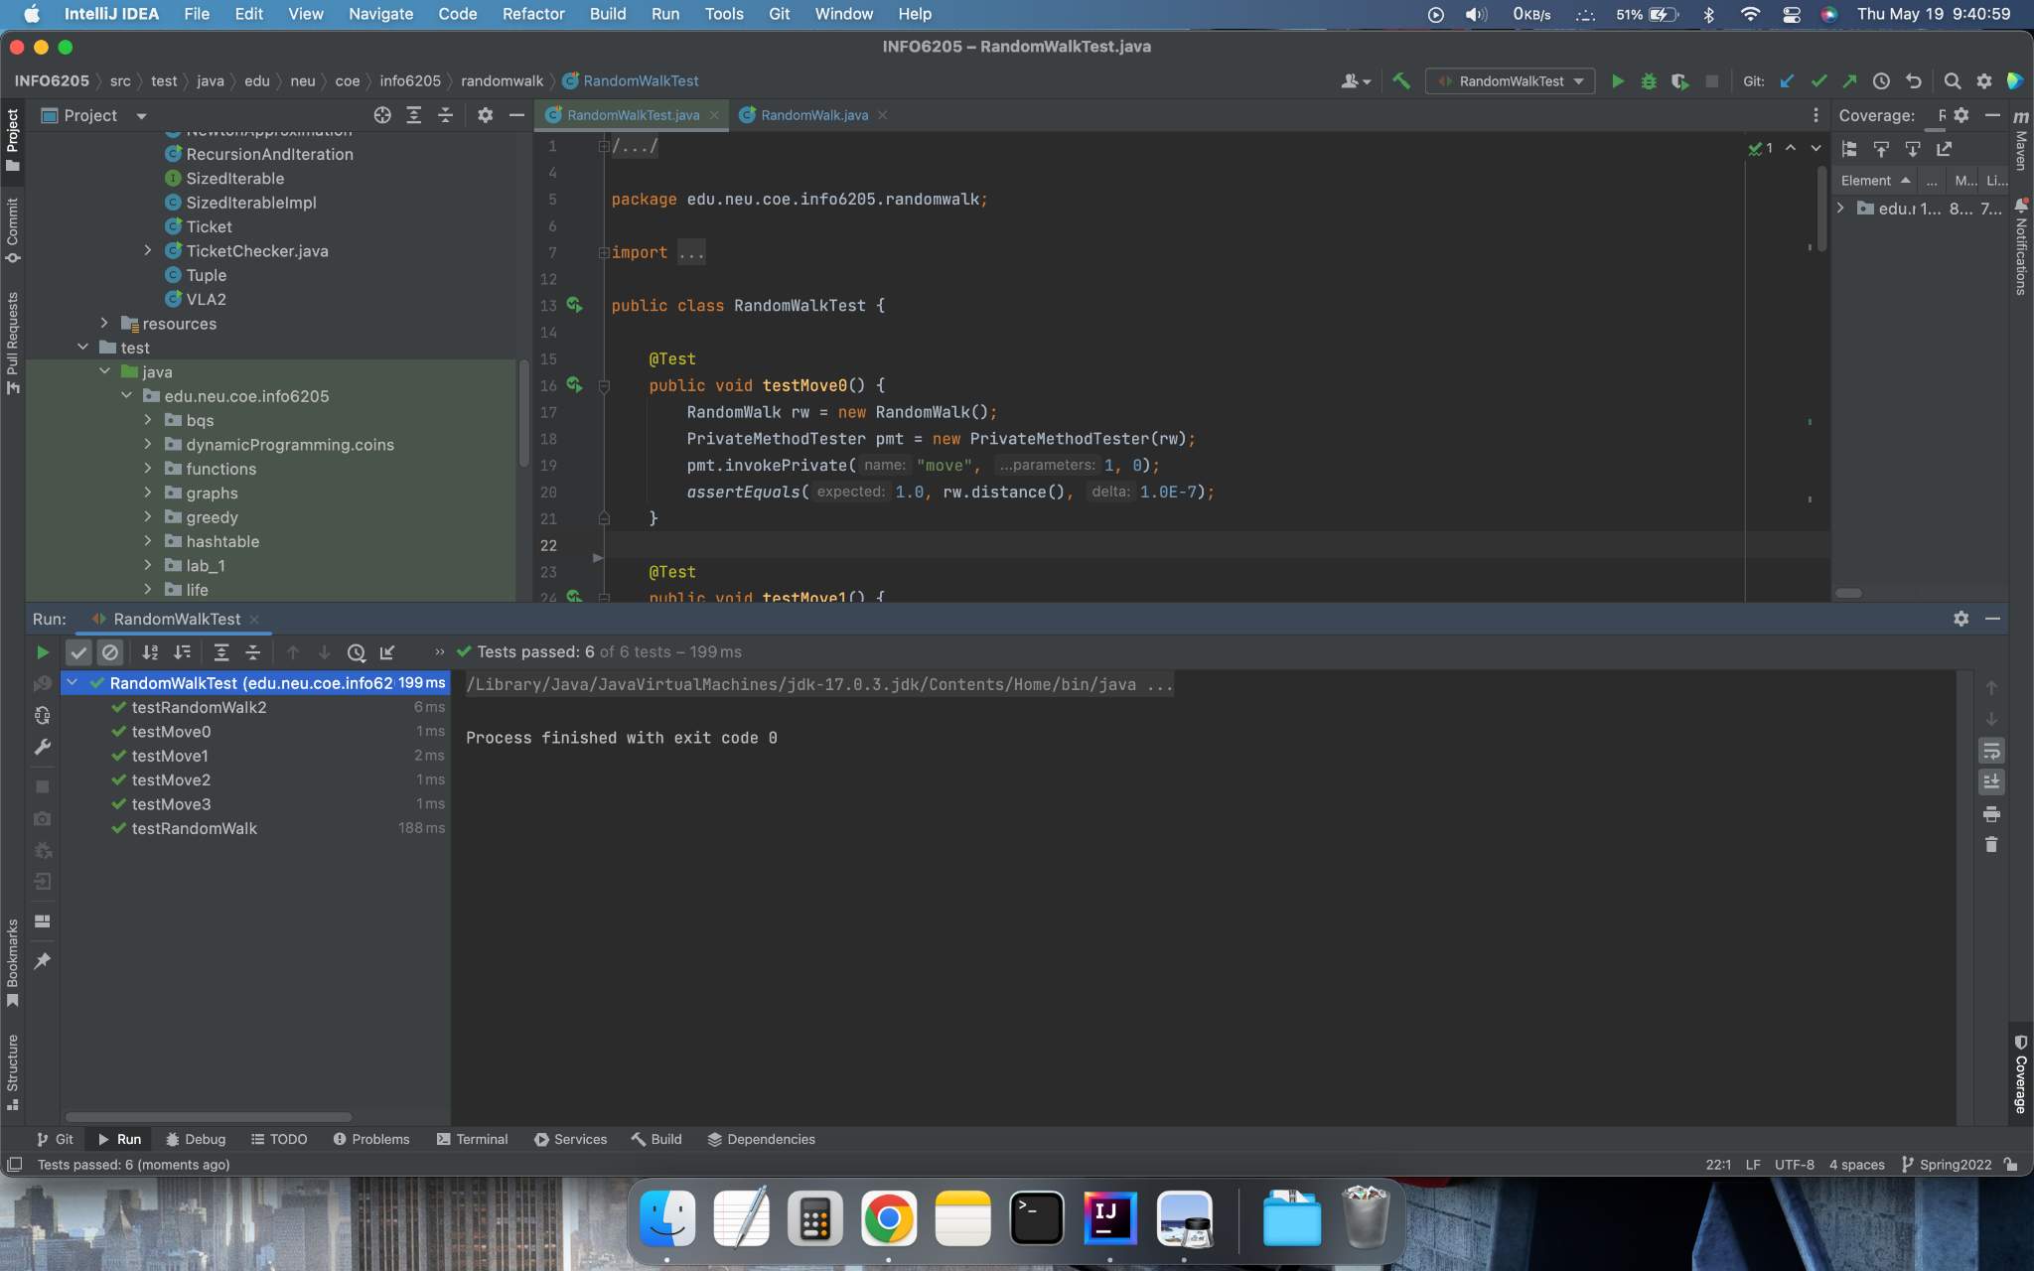

**Modified Main Method to run custom test cases**

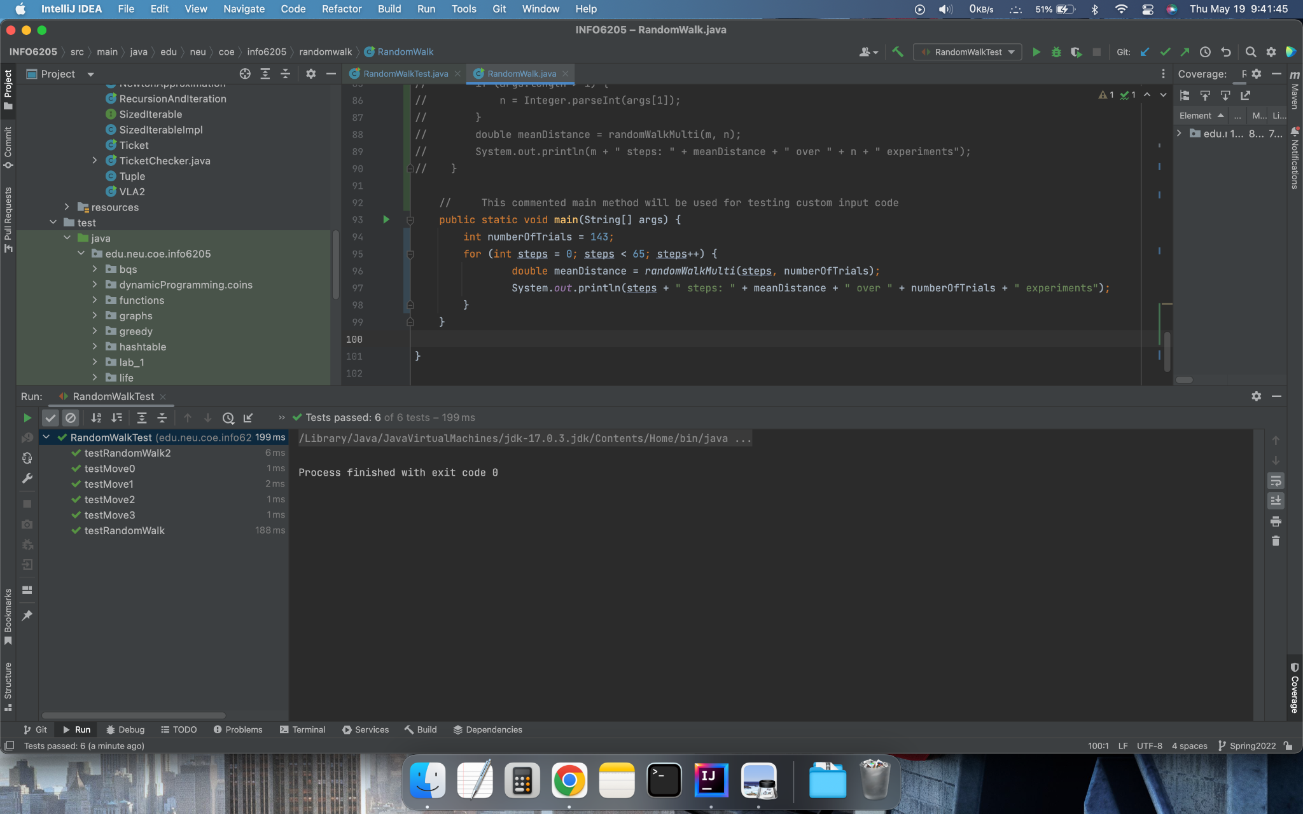

**Console Output of Main method with custom tests running for steps ranging from 0 to 65 and with each steps count running for 143 Trials ( Arbitrarily chosen)**

**Attached are Excel Files with the data and also the curve showing the trend of the mean distance**

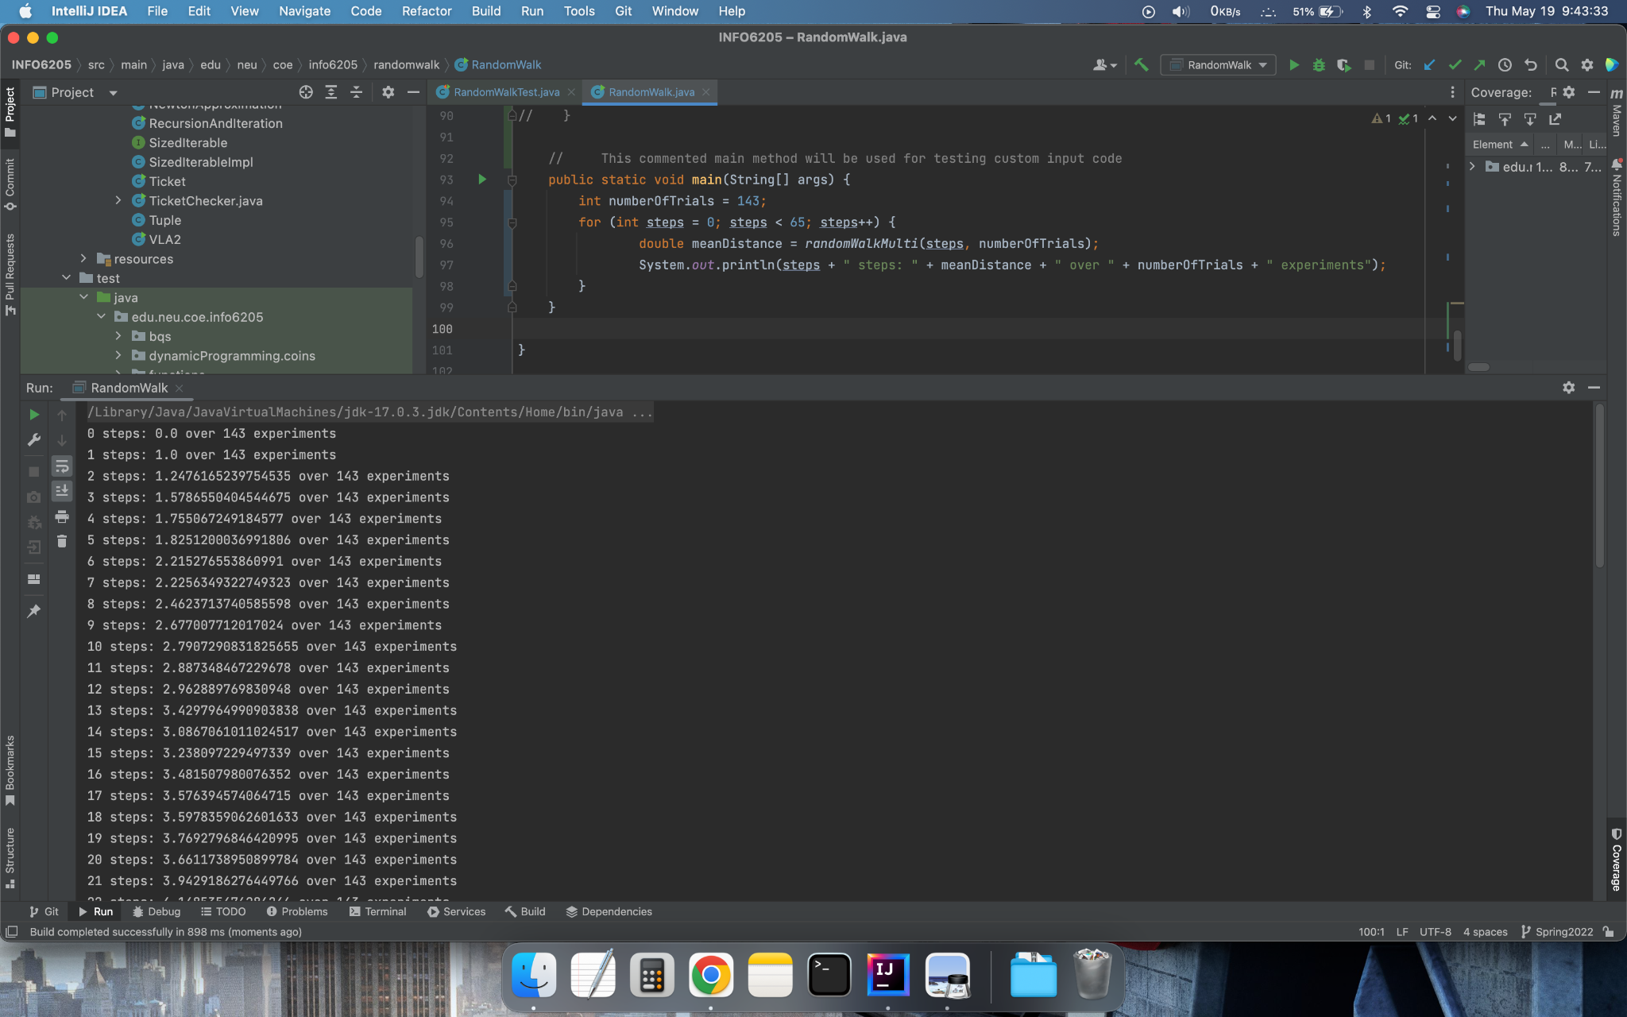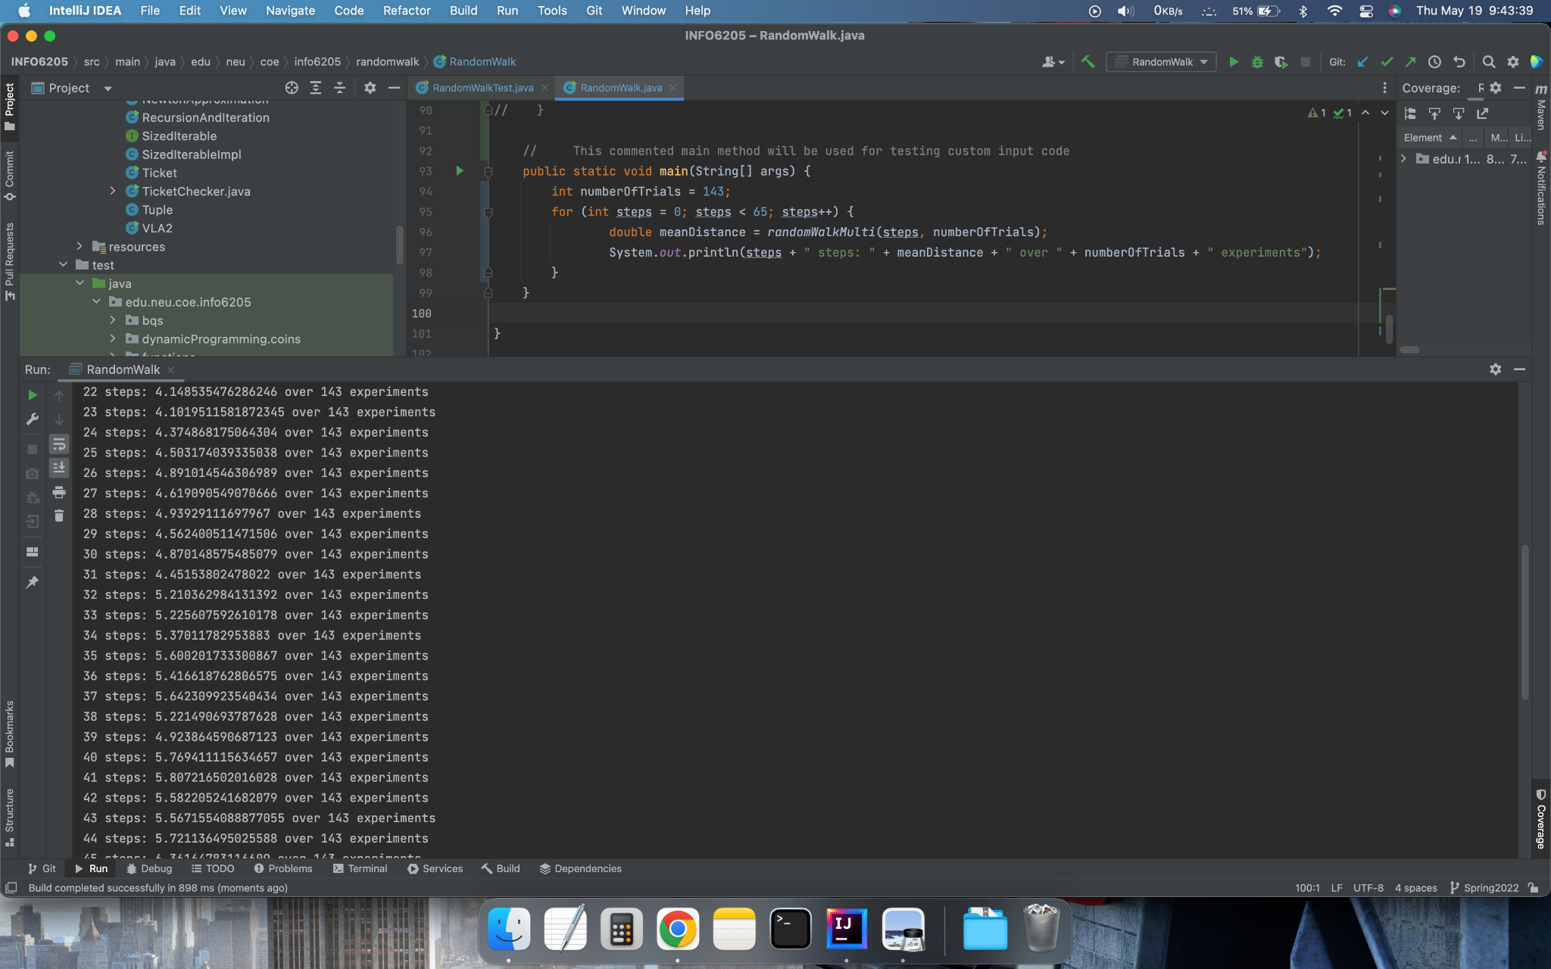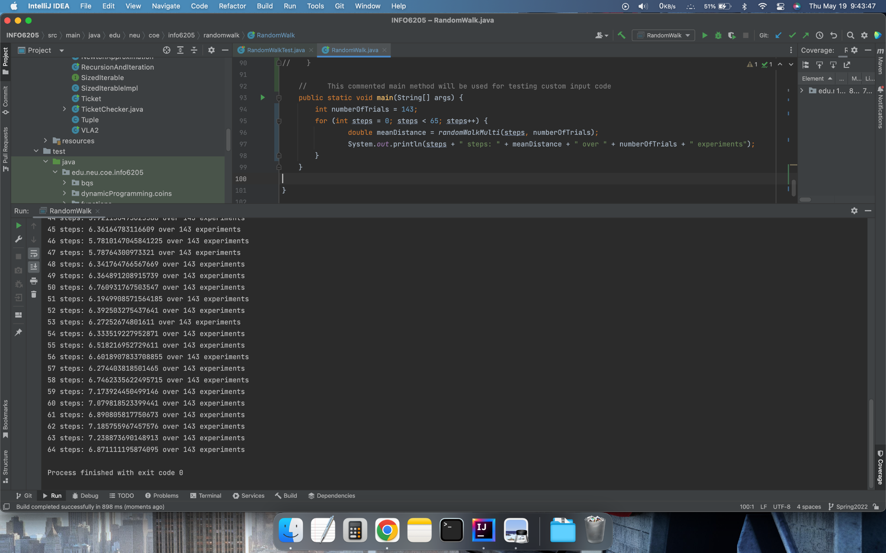

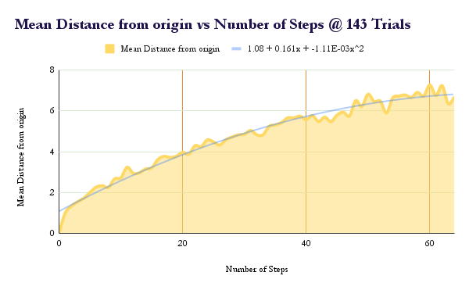

**Excel File**

[**Assignment 01 Data**](https://github.com/akhilsaikoppanatham/psa-info6205/blob/48676fb577b0ad7c99532b2e12b8dadedb283b09/Assignment%20Deliverables/Assignment%201/Test%20Custom/INFO6205%20Assignment01.xlsx)

**Conclusion**

The mean distance showed a growth in small increments for the experiments run from 0 to 65 steps and each step running for 143 trials. From the graph above the trend also appears follows a curve

**y = 1.08 + (0.161)(x) + (-1.11E-03)(x^2)**

which is a second degree quadratic equation